Introduction
The Apache HTTP Server, widely known as Apache, stands as one of the most established and prevalent web servers globally. As an open-source project maintained by the Apache Software Foundation, Apache has become a cornerstone in web infrastructure due to its robustness, versatility, and extensive feature set. This detailed walkthrough will guide you through the process of configuring Apache, from installation to optimization, ensuring a secure and efficient setup for hosting web applications.
In setting up our Apache web server, we took several crucial steps to ensure a secure and efficient configuration. We configured security headers to protect against common web vulnerabilities and specified where error files should be logged, making it easier to monitor and troubleshoot issues. We also installed Certbot to manage SSL/TLS certificates, enabling secure HTTPS connections for our site. To further secure the server, we installed and configured the firewall to grant Apache the necessary permissions, allowing legitimate web traffic while blocking unauthorized access. These implementations were vital in establishing a secure and reliable server environment. Below would be a detailed walkthrough of our process in configuring our Apache web server.

Install Apache
Update your package list: Before the installation of apache we run a “sudo apt install update” to ensure packages are up to date

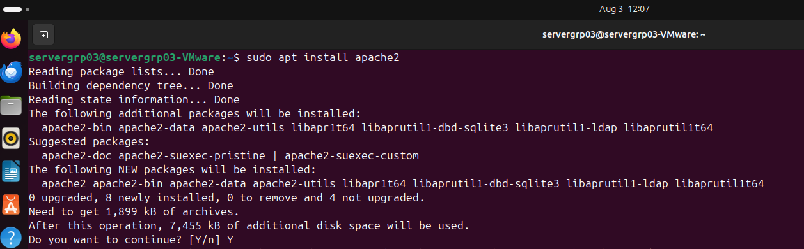
Install Apache: After we use the package manager to install apache 2 onto our Ubuntu system with “sudo apt install apache2” command
Check if Apache is running: Upon successful installation we make sure to enable and start apache with the sytemctl enable and start commands depicted below. It should indicate that it is active once running

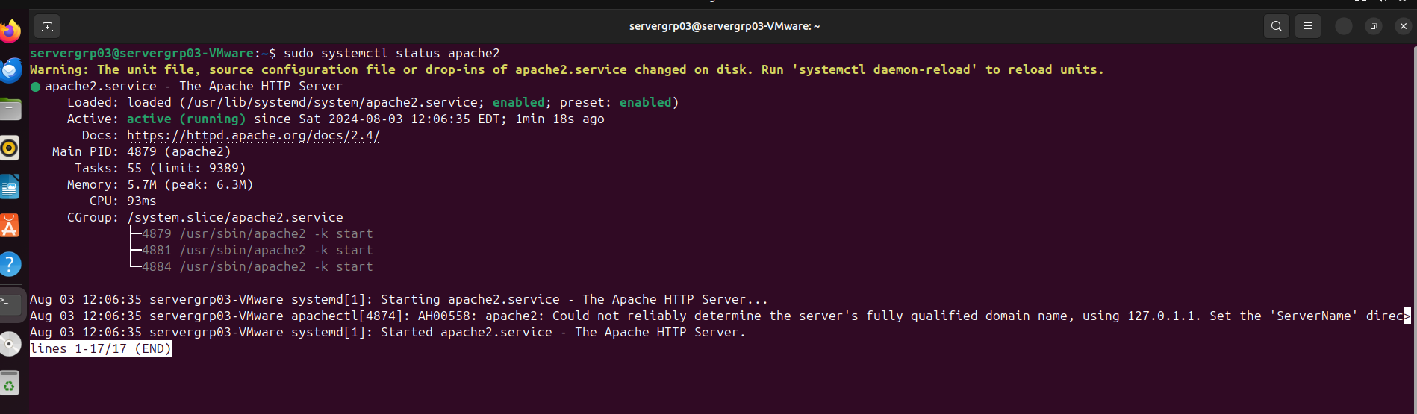

Start Apache and enable it to start on boot:

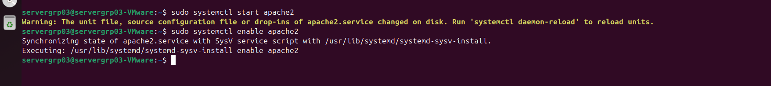

Configure Apache
Basic Configuration Files:
Main configuration file: /etc/apache2/apache2.conf
Set up virtual hosts:
We created a new configuration file for site locally using “sudo nano /etc/apache2/sites-available/projectgrp3.conf” within the file we set up a virtual host for the Apache web server, specifying how the server should handle requests for the domain projectgrp3.local. It defines the document root directory /var/www/projectgrp3 where the website's files are stored, sets permissions to allow all users access to the content, and enables the use of .htaccess files for overriding server settings. Additionally, it configures error and access logging for the site, directing logs to specific files for monitoring and troubleshooting purposes.
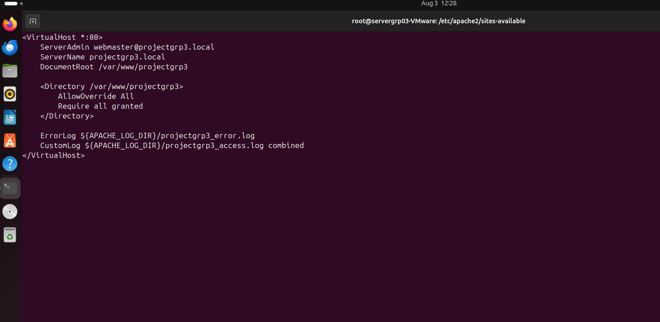

With these changes, Apache will serve content from the /var/www/projectgrp3 directory when accessing http://projectgrp3.local in your browser. Make sure to create the projectgrp3 directory and add your website files there.
Enable the site and reload Apache
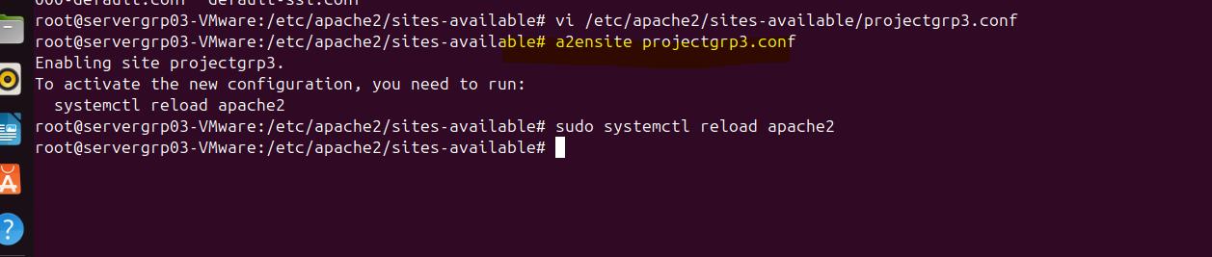

Secure Apache

1.Upgrade
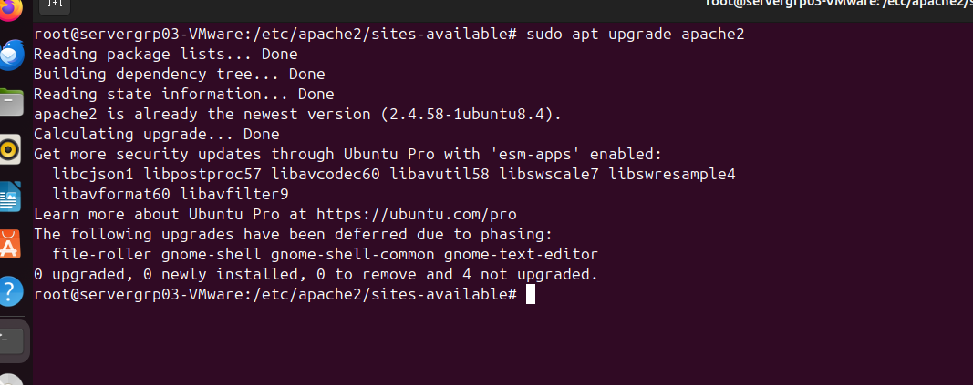
2.Configure Security Headers:
Edit your virtual host configuration or the main configuration file:
ServerTokens Prod
ServerSignature Off
TraceEnable Off

# Additional security headers
Header always set X-Content-Type-Options "nosniff"
Header always set X-Frame-Options "SAMEORIGIN"
Header always set X-XSS-Protection "1; mode=block"

Setting ServerTokens Prod and ServerSignature Off minimizes the server's exposure by hiding detailed version information, making it harder for attackers to exploit specific vulnerabilities. TraceEnable Off disables the TRACE HTTP method, preventing potential cross-site tracing attacks. The additional security headers provide further protection: X-Content-Type-Options "nosniff" prevents MIME type sniffing, X-Frame-Options "SAMEORIGIN" prevents clickjacking by disallowing the site from being framed by other sites, and X-XSS-Protection "1; mode=block" helps prevent cross-site scripting attacks by enabling the browser's XSS filtering
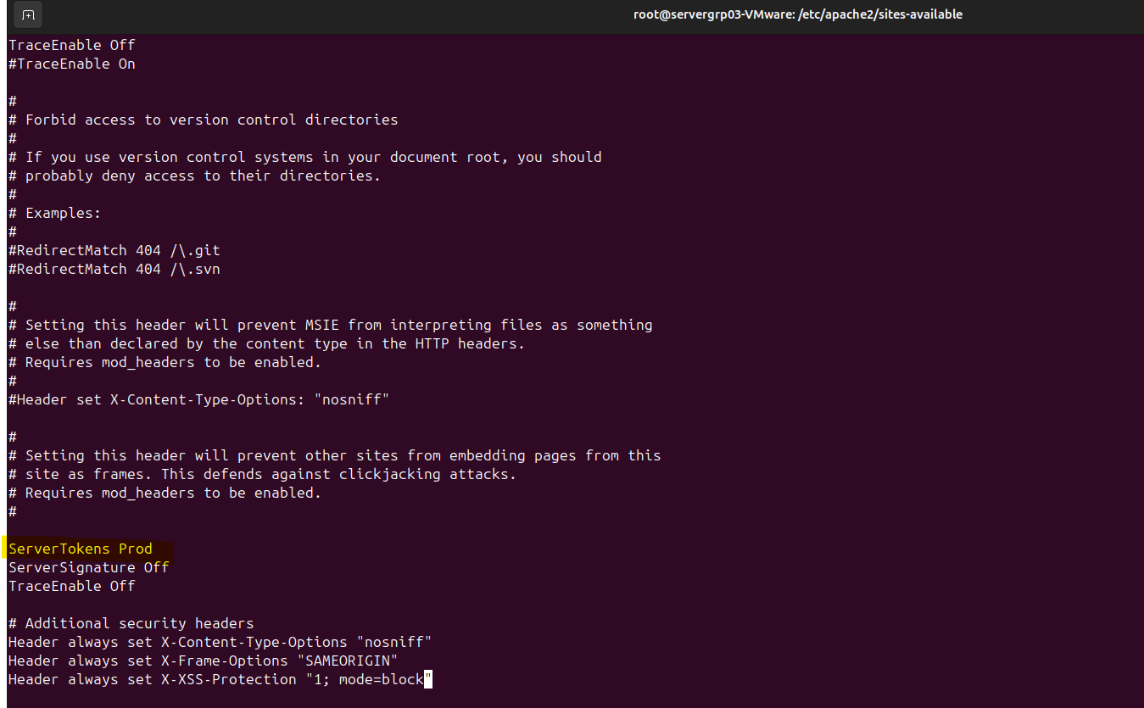

3.Use HTTPS:
Install Certbot for Let's Encrypt SSL certificates:
Using the command sudo apt install certbot python3-certbot-apache, we automate the process of obtaining and managing SSL/TLS certificates from Let's Encrypt. This package streamlines the setup and maintenance of secure connections for our web server.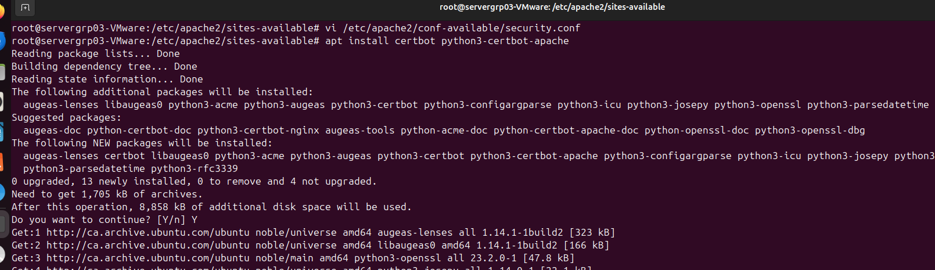

Harden the System
Install and Configure Firewall
Command to install firewall-sudo apt install ufw
Allow necessary ports:
Granting permission with the command sudo ufw allow 'Apache Full' allows HTTP (port 80) and HTTPS (port 443) traffic, enabling the Apache web server to serve both unencrypted and secure, encrypted connections. This is essential for providing access to web services and protecting sensitive information through encryption.
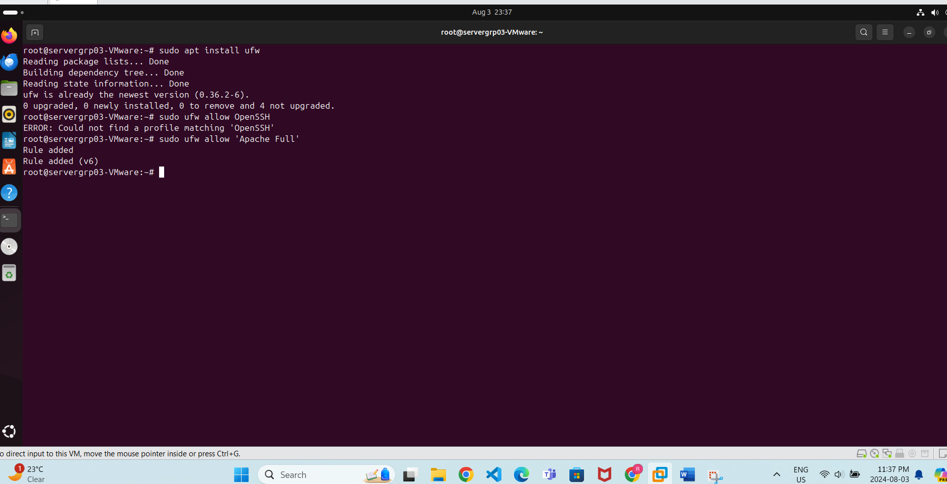

After we Enable ufw and run below commands, it validates the firewall rules and ensure that the rules have been applied. Commands:
sudo ufw enable
sudo ufw status
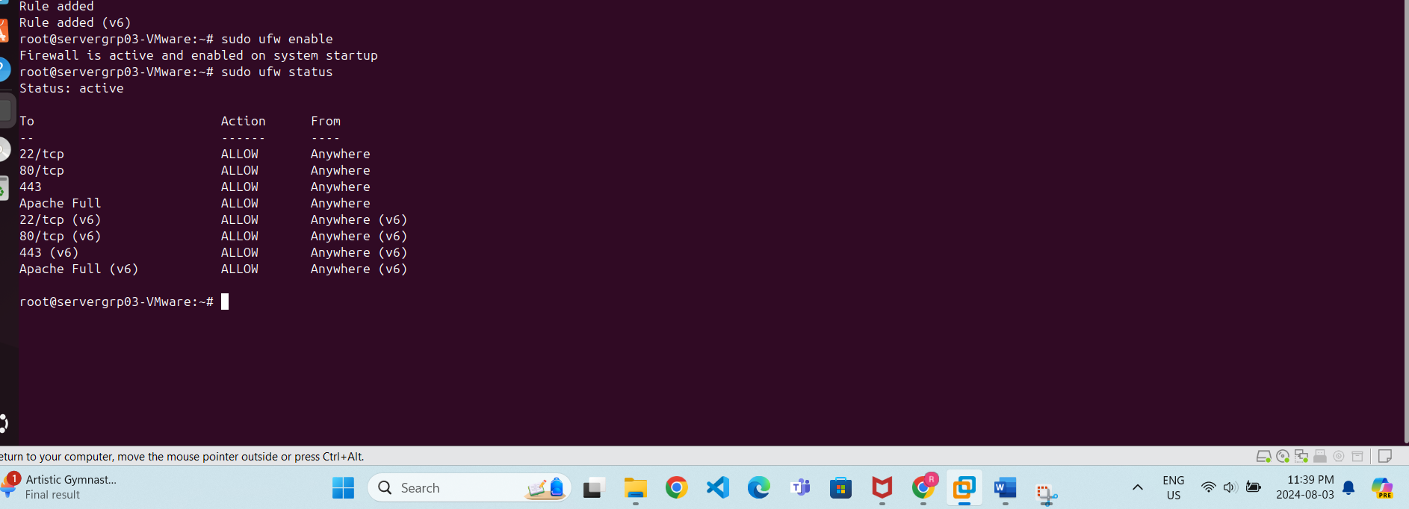

Justification
In today's digital landscape, ensuring the security of a web server is paramount. The configurations and measures discussed above are crucial for protecting sensitive information and maintaining the integrity and availability of the web services provided. By implementing strong security headers, controlling access through firewalls, and securing communications with SSL/TLS certificates, we have built a robust defense against potential threats.

WORDPRESS
To set up WordPress on Ubuntu, connect it with Apache, and ensure it is highly secured, follow these steps:

sudo mkdir -p /var/www/projectgrp3
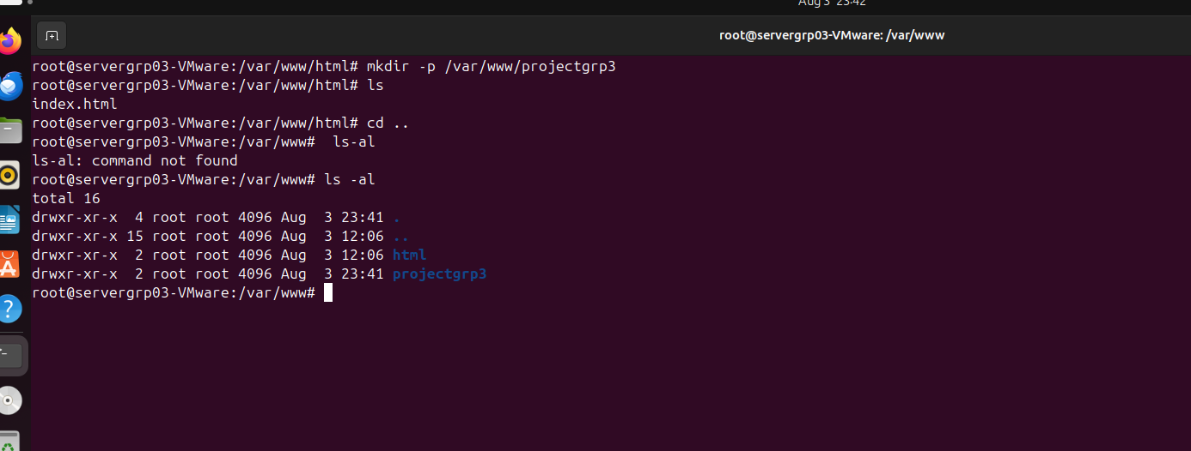

Permission
sudo chown -R www-data:www-data /var/www/projectgrp3
sudo chmod -R 755 /var/www/projectgrp3

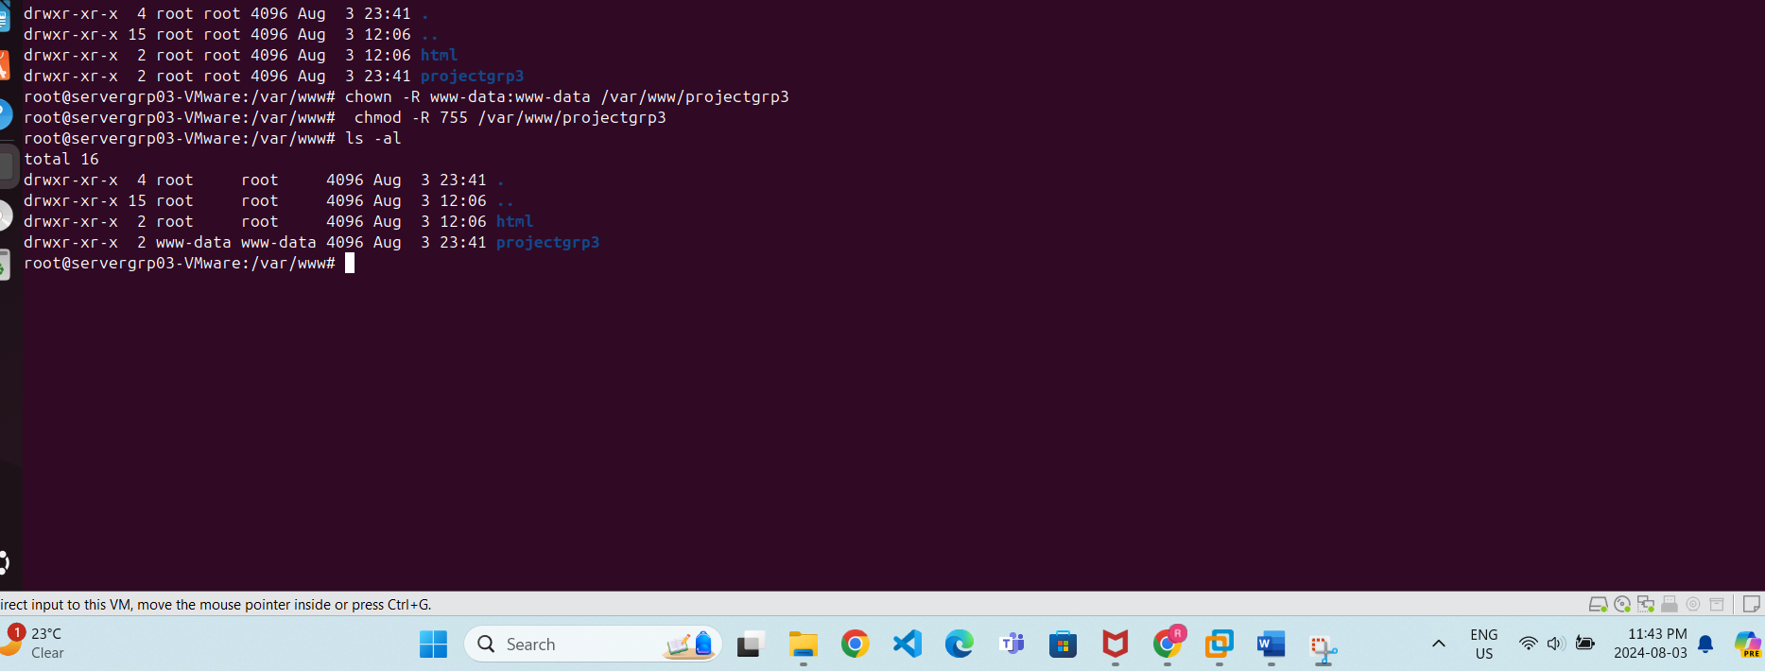

Create a Virtual Host Configuration: already created in apache config step
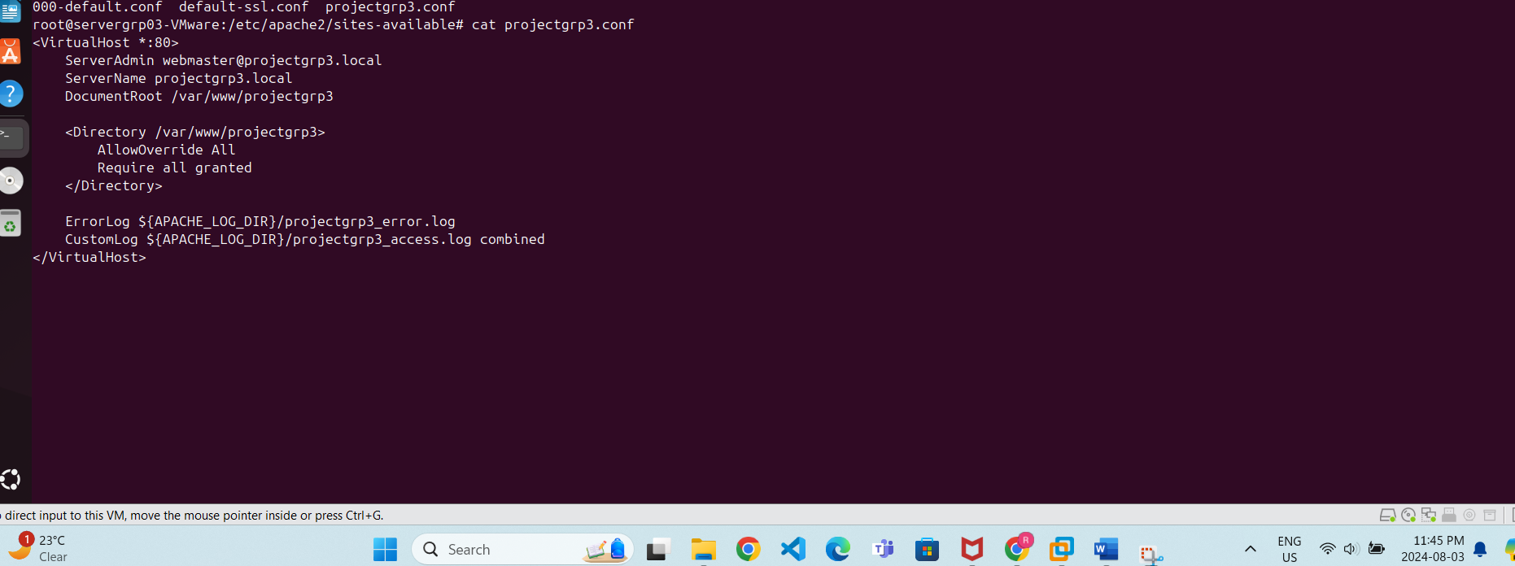

Install MySQL
sudo apt install mysql-server
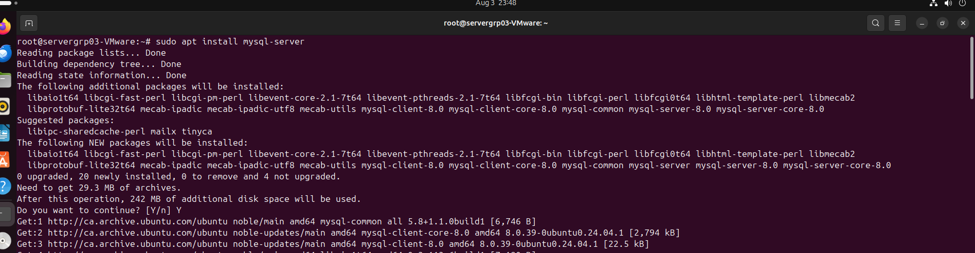

Secure mysql
sudo mysql_secure_installation
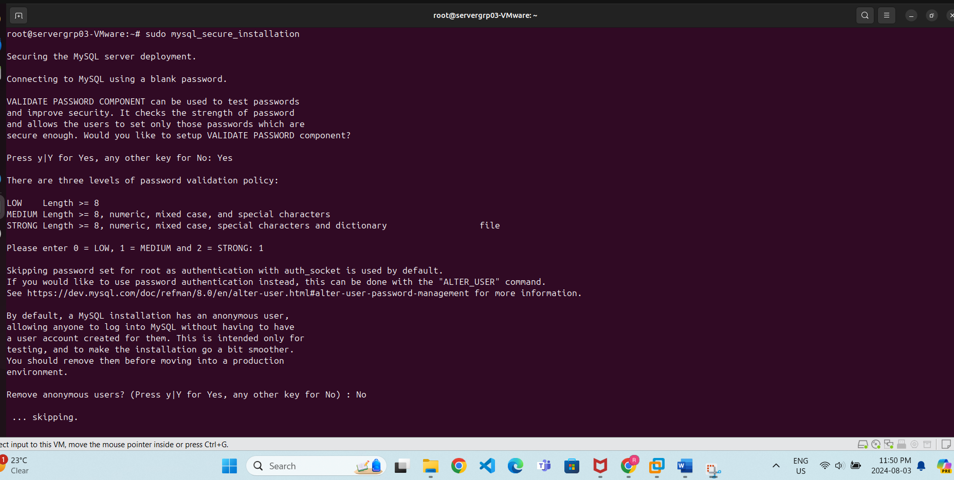
Create a MySQL Database and User for WordPress:
Password is 12345
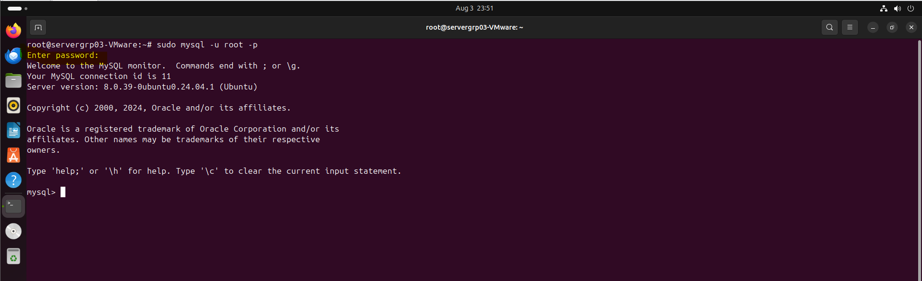

CREATE DATABASE wordpress;
CREATE USER 'wp_user'@'localhost' IDENTIFIED BY 'Str0ng_P@ssw0rd!';
GRANT ALL PRIVILEGES ON wordpress.* TO 'wp_user'@'localhost';
FLUSH PRIVILEGES;
EXIT;
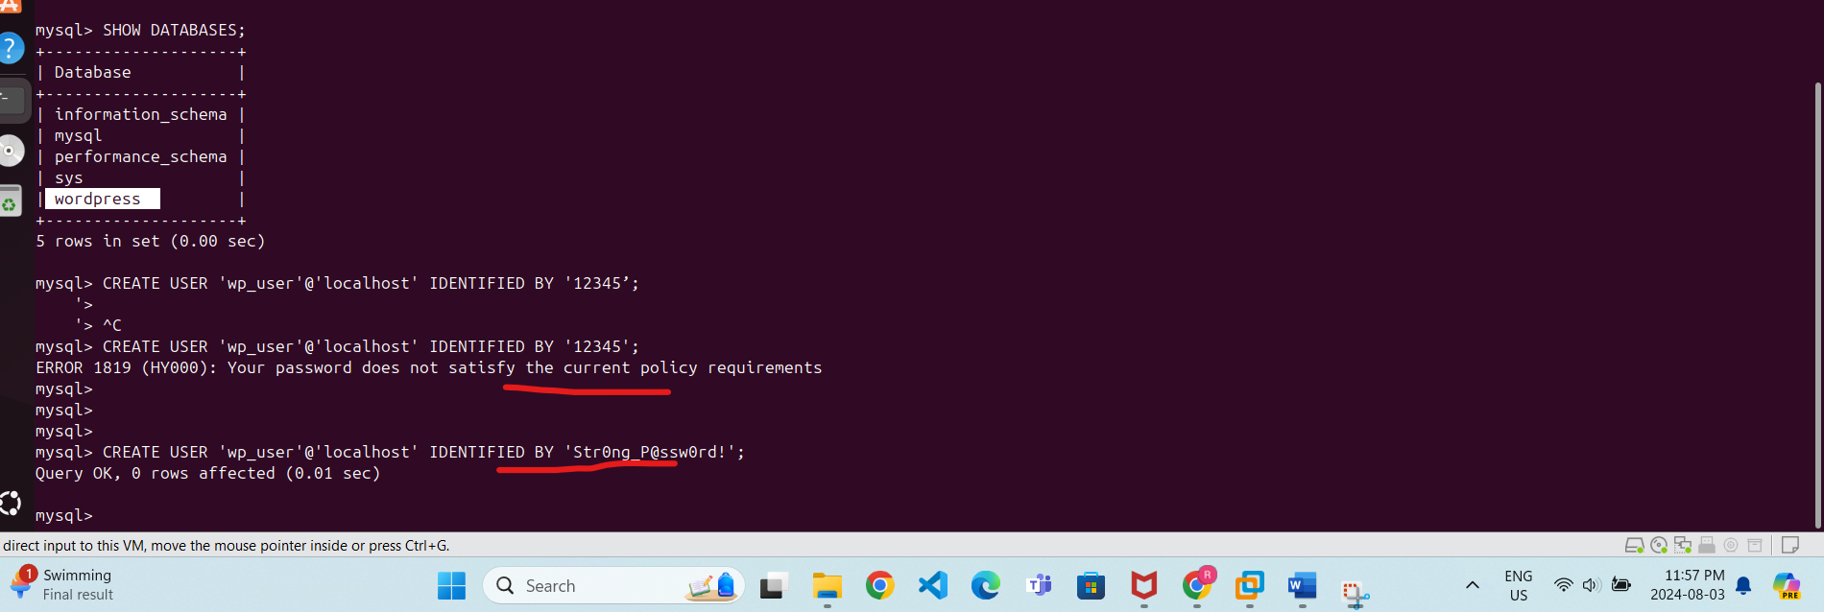
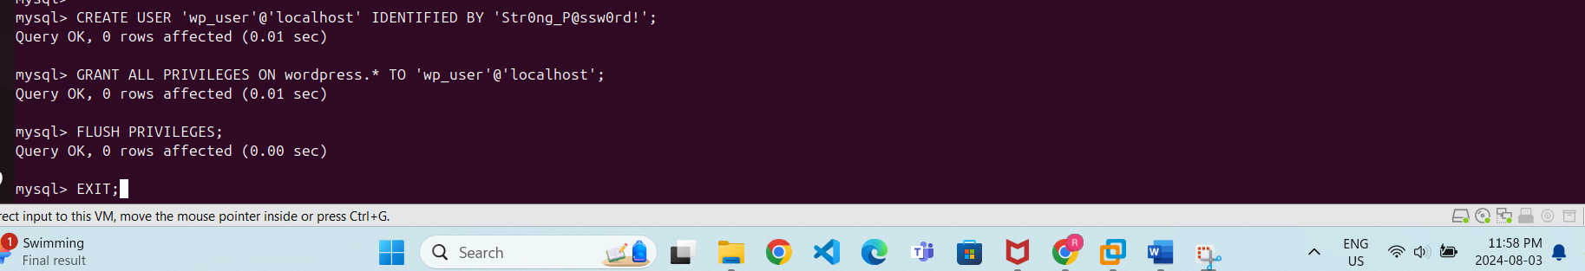

3. Install PHP and Required Extensions
sudo apt install php libapache2-mod-php php-mysql php-gd php-mbstring php-xml php-xmlrpc php-cli
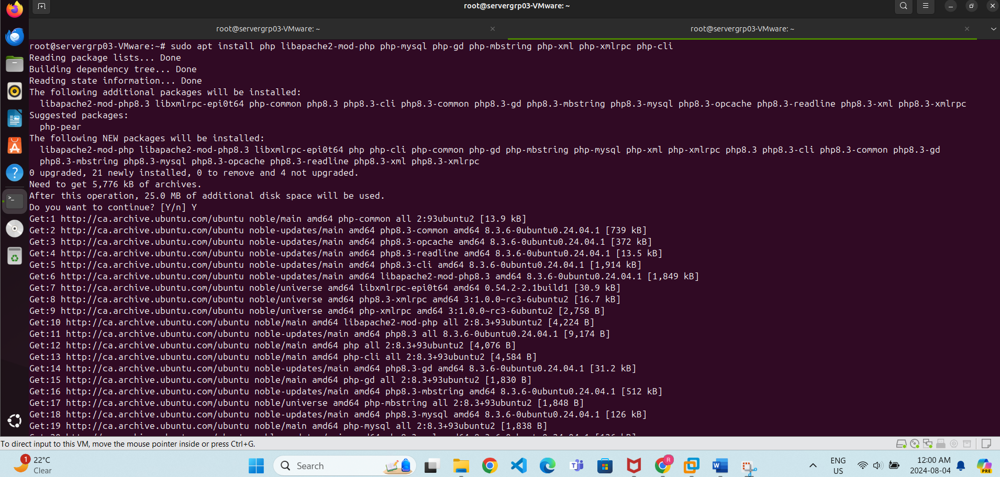

Restart apache
sudo systemctl restart apache2
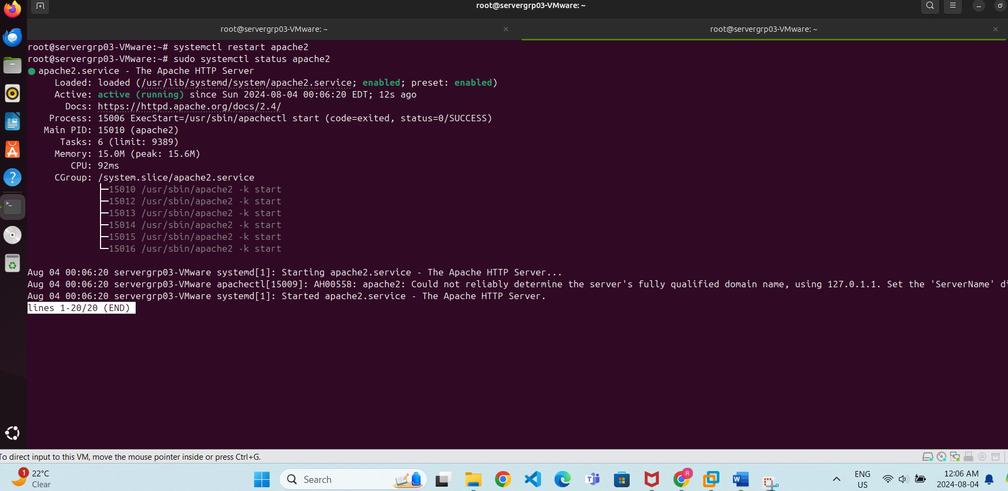

Install WordPress
wget https://wordpress.org/latest.tar.gz
tar xzvf latest.tar.gz
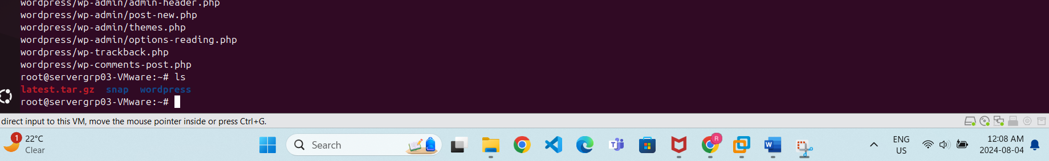

Move WordPress Files to the Project Directory:
sudo cp -r wordpress/* /var/www/projectgrp3/
Create the WordPress Configuration File:
sudo cp /var/www/projectgrp3/wp-config-sample.php /var/www/projectgrp3/wp-config.php
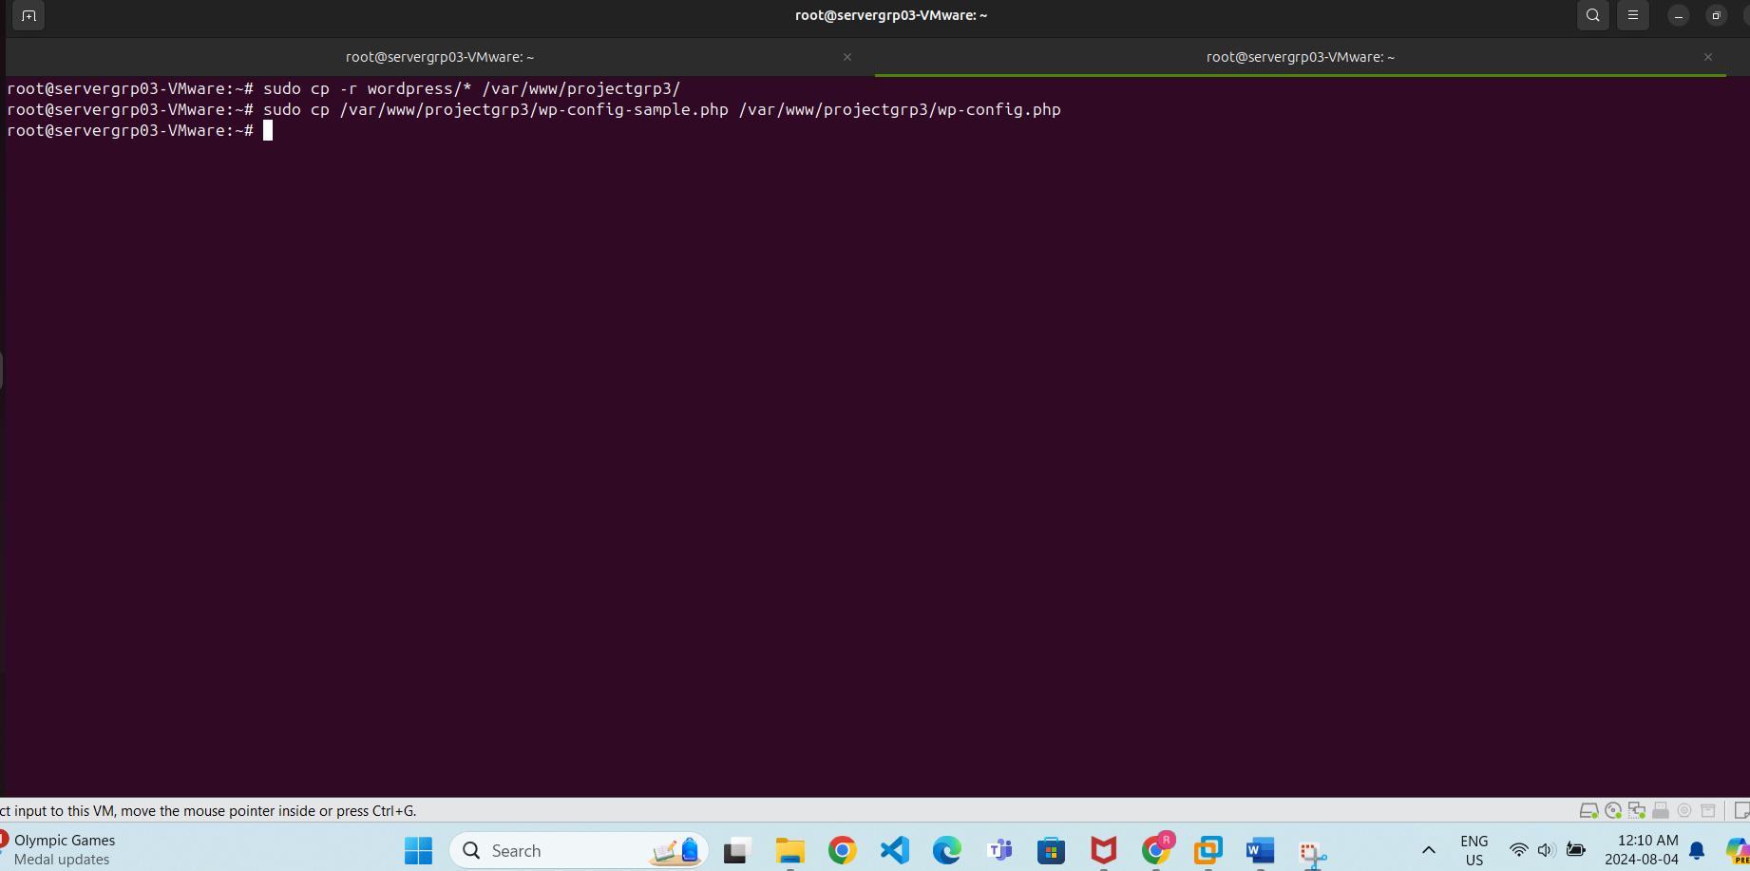

Edit the WordPress Configuration File:
sudo nano /var/www/projectgrp3/wp-config.php
define('DB_NAME', 'wordpress');
define('DB_USER', 'wp_user');
define('DB_PASSWORD', ' Str0ng_P@ssw0rd!’);
define('DB_HOST', 'localhost');
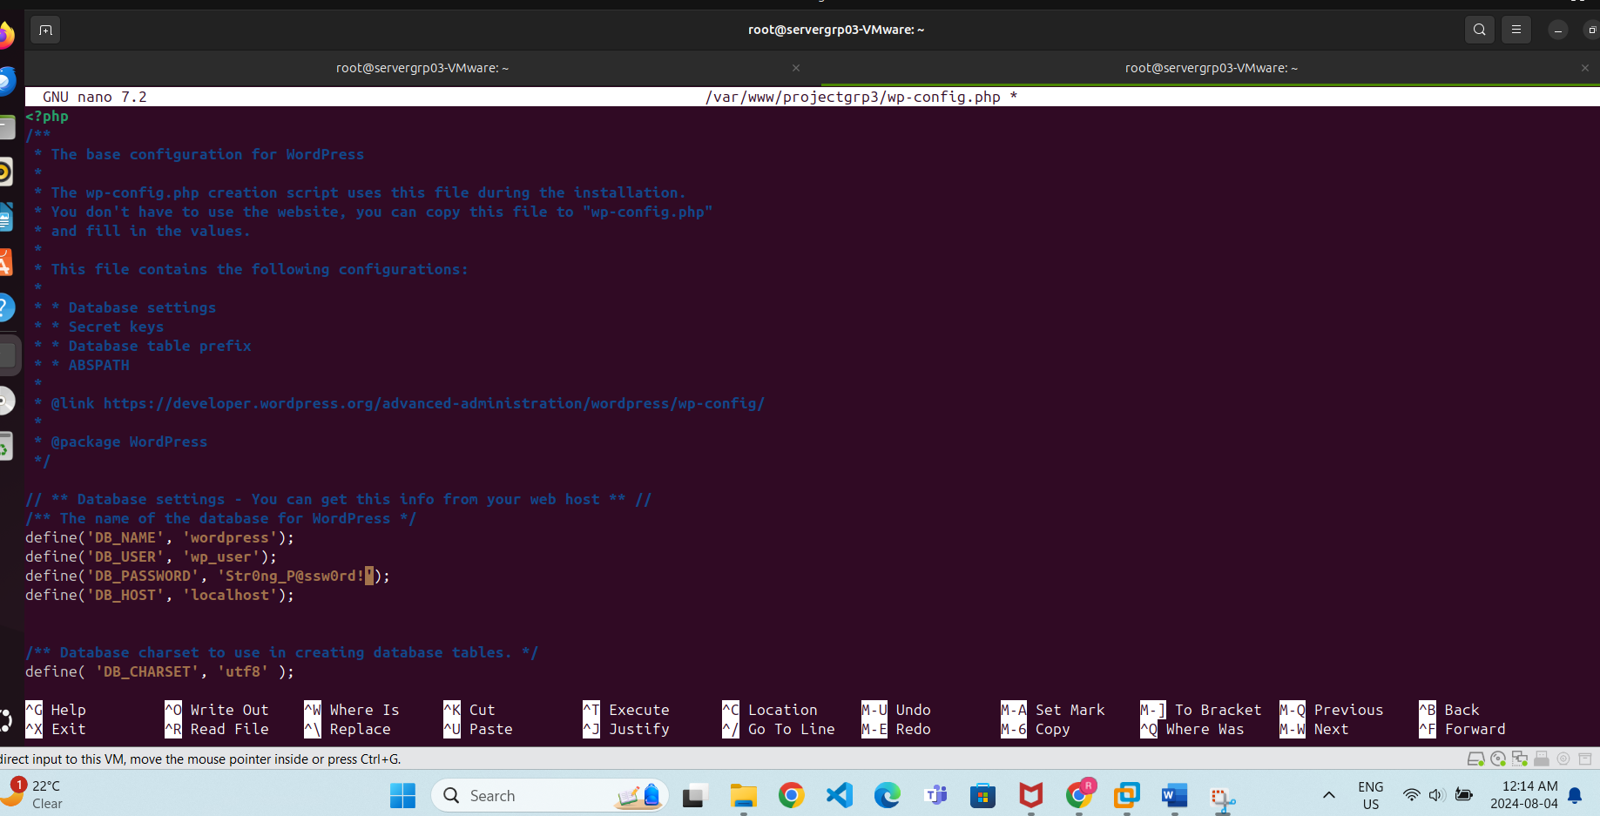

Complete the WordPress Installation
- Open your browser and navigate to http://projectgrp3.local.
- Follow the WordPress installation wizard to complete the setup.

Password: wjxMcN'9@9zxYaE
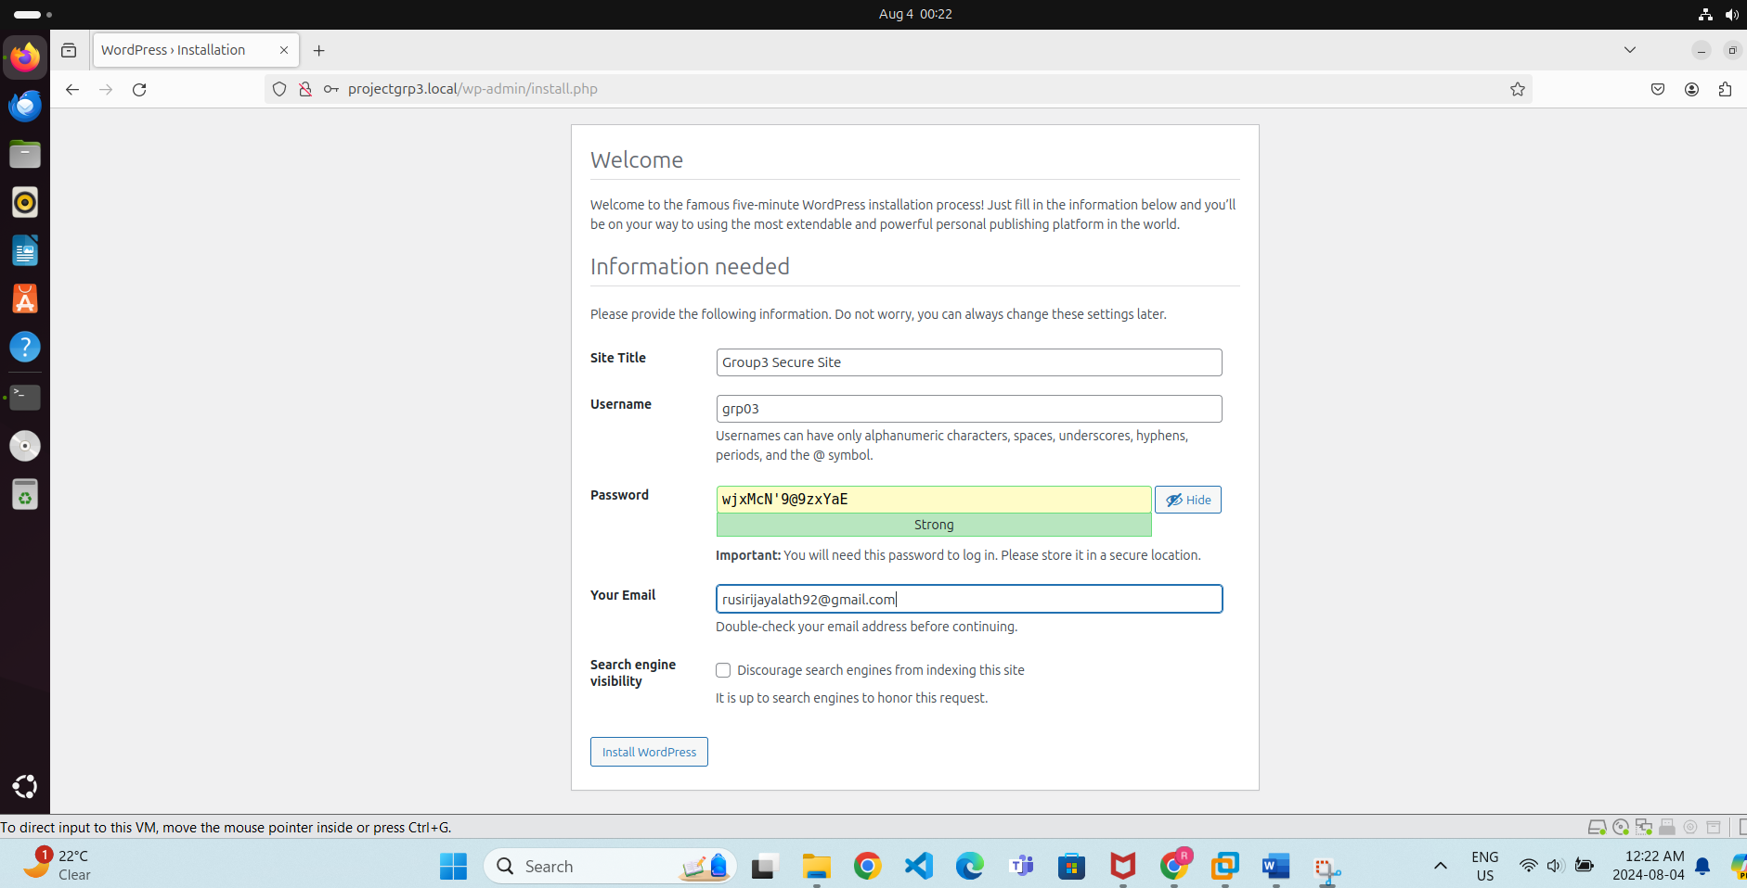

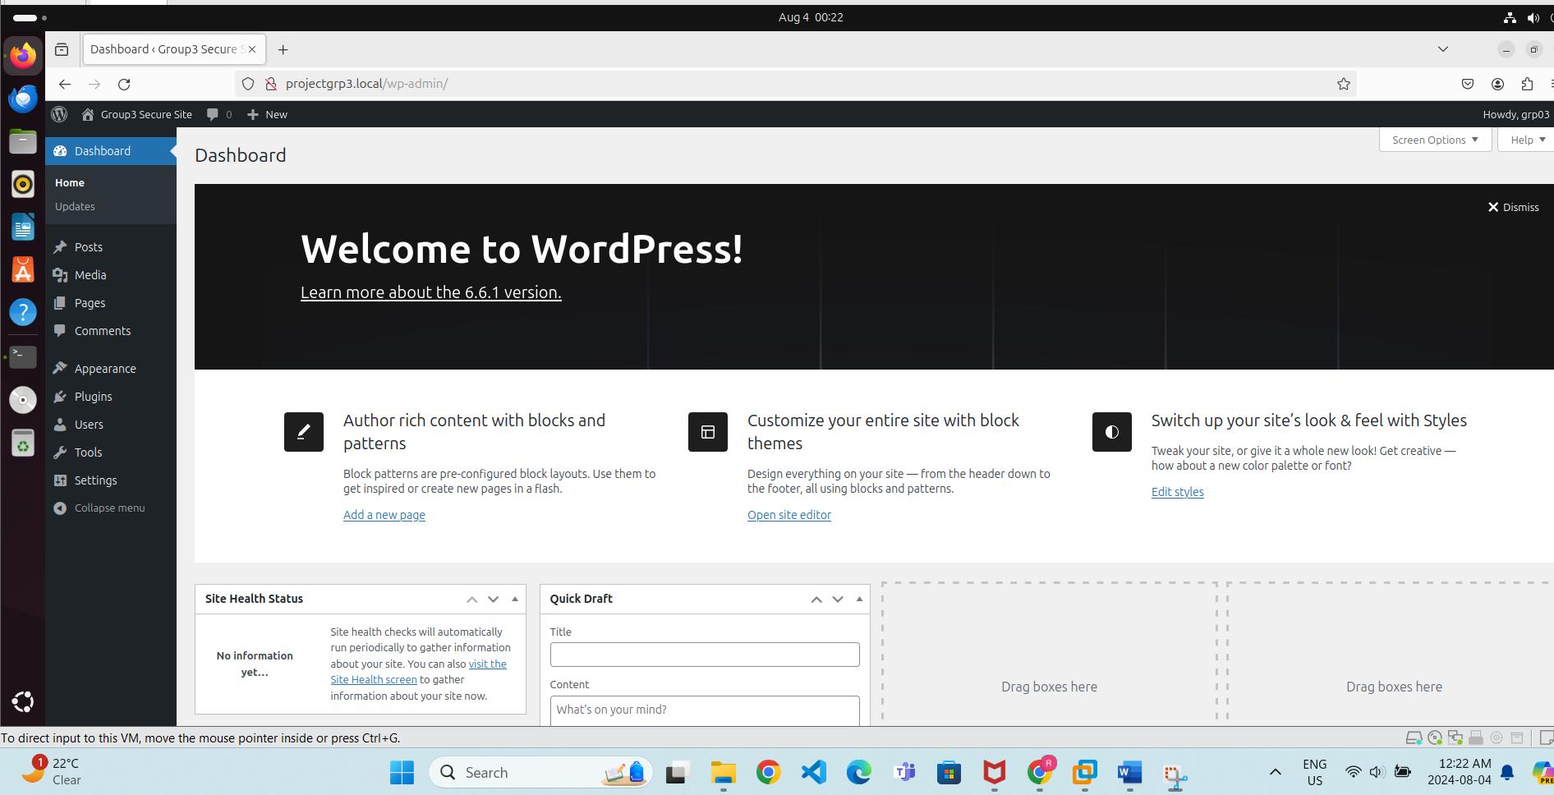

. Secure and Harden the System
Set Correct Permissions for WordPress:
sudo find /var/www/projectgrp3 -type d -exec chmod 755 {} \;
sudo find /var/www/projectgrp3 -type f -exec chmod 644 {} \;
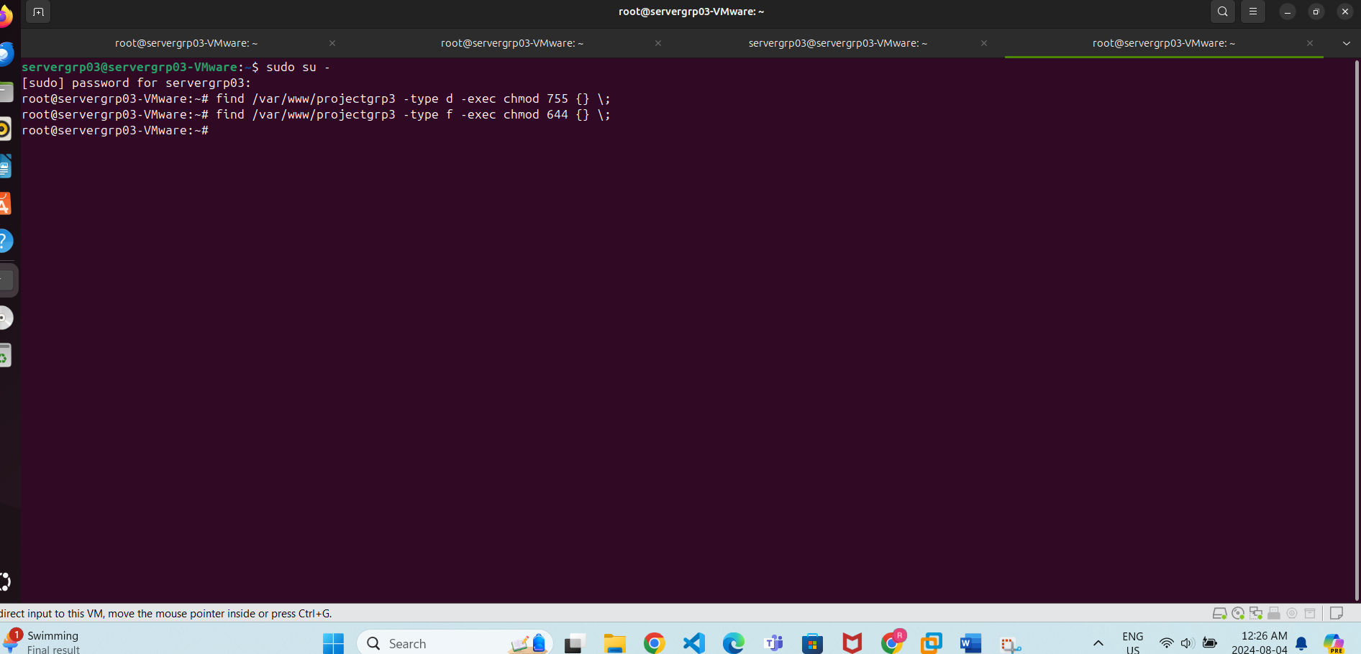
To enhance the security of your WordPress site, you can use security plugins like Wordfence. Here’s how to install and configure these plugins:
• Log In to WordPress Admin: Go to http://projectgrp3.local/wp-admin and log in with your admin credentials.
• Navigate to Plugins: In the left-hand menu, go to Plugins > Add New.
• Search for Wordfence: In the search bar, type Wordfence Security.
• Install and Activate: Click Install Now and then Activate once the installation is complete.
Firewall: Configure the Web Application Firewall (WAF). It’s recommended to use the “Extended Protection” option if available.
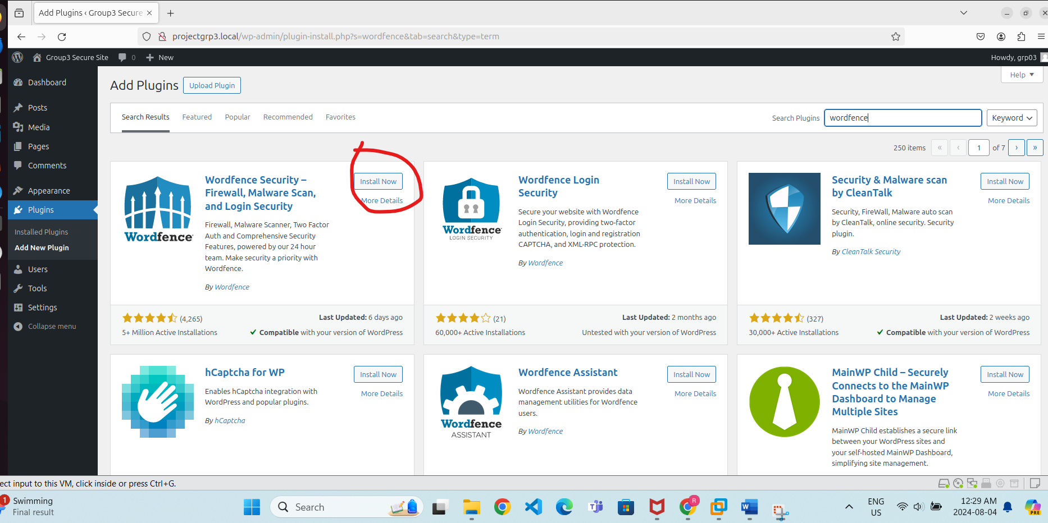

For Local Development (e.g., projectgrp3.local)
- Hostname: If you’re using a local development environment with a hostname like projectgrp3.local, you don’t need to specify this in the Wordfence firewall configuration. Wordfence should automatically detect and configure itself.
